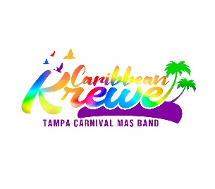
CARIBBEAN KREWE PARTICIPANT MAS BAND APPLICATION
Website: www.tampabaycaribbeancarnival.com
MLK Parade, January 20th, 2020
Gasparrella Parade, January 25, 2020
Sant’ Yago Knight Parade, February 8th, 2020

FIRST NAME: ________________________ LAST NAME: _______________________
EMAIL ADDRESS: _________________________________________________________
TELEPHONE NUMBER: _________________
- ALL MASQUERADERS ARE EXPECTED TO PROVIDE THEIR OWN COSTUME IN GOOD CONDITION
- PLEASE NOTE THERE IS NO REFUND
- BEADS ARE OPTIONAL
- DO NOT MAIL CASH

REGISTRATION FEE: $150.00 per parade
ENTITLEMENTS
Insurance, Food, Drinks, and Wrist Band
Each person must fill out an application.
Money Orders and Certified Checks are accepted. NO PERSONAL CHECKS
A Deposit of $75.00 due by December 1st, 2019.
Mail payment to:
Tampa Bay Caribbean Festival, Inc.
P.O. Box 47525
New Tampa Station
Tampa, FL 33647

For Information call: (917) 916-2094, (813) 447-7081, (813) 766-3495
Email: luvjen12@yahoo.com

Signature: _____________________________ Date: ___________

